**MIS 49 PROJECT PROPOSAL**

**QUESTİON BANK PROJECT(KOTLIN)**

**Created by** Beyazıt Bestami ERGÜN (2016502150)

<https://bestergun.github.io/49M/>

**Brief Indroduction:** The project’s aim is to learn computer network basics. My aim is to utilize his/her free time.

**Project background:** People generally do not have free time to solve problem to enforce thier skills. With this application, people enable to reinforce their knowledge by clicking.

**Entry Page**

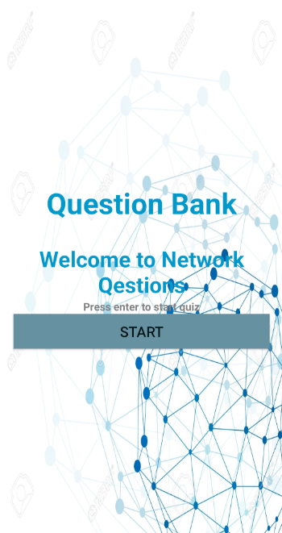

**Question Page**

